

MINI PROJECT (2020-21)

ON

VOICE BASED EMAIL FOR VISUALLY IMPAIRED

**AUTHOR:** SANA AFREEN

ABSTRACT

Internet has become one of the basic amenities for day-to-day living. Every human being is widely accessing the knowledge and information through internet. However, blind people face difficulties in accessing these text materials, also in using any service provided through internet. The advancement in computer based accessible systems has opened up many avenues for the visually impaired across the globe in a wide way. Audio feedback based virtual environment like, the screen readers have helped Blind people to access internet applications immensely. We describe the Voicemail system architecture that can be used by a Blind person to access e-Mails easily and efficiently. The contribution made by this research has enabled the Blind people to send and receive voice based e-Mail messages in their native language with the help of a computer.

INTRODUCTION

The introduction of Internet has revolutionized many fields, it has made life of people easy that people today have access to any information they want easily. Communication is one of the major fields which is highly changed by Internet.

Emails are the most dependable way of communication over internet, for sending and receiving some important information. But there is a certain norm of humans to access the Internet and the norm is you must be able to see.

But there are also differently abled people in our society who are not gifted with what you have. There are some visually impaired people or blind people who can’t see things and thus can’t see computer screen or keyboard.

A survey has shown that there are more than 210 million visually impaired people around the globe. These people don’t know how to send a mail or they can’t read the mails they received. They always have to rely on third person (who can see) on sending mail and reading the mails for them. But this cannot happen every time, as visually impaired person might not find someone for help. So the right way to deal with this problem is by having a system in which visually impaired people can operate mail through speech.

OBJECTIVE

This project is a basic-python based application which is specifically designed for visually impaired people. This application provide a voice based email service where they could read and send mail on their own, without any guidance through their gmail accounts. This system can be used by a blind person to access mails easily and adeptly. Hence, this can decrease the dependence of visually challenged person on other individual for their activities associated to mail.

This application will be a python-based application for visually impaired person using the IVR - Interactive voice response, thus they can control their mail accounts by using their mail only and be able to read, send and perform all the other useful tasks. The system will ask user for voice commands to perform certain action and user will respond to it.

**THE MAIN ADVANTAGE:**

The use of keyboard is completely eliminated, here the user will only respond through voice only.

REQUIREMENTS

**LANGUAGE USED:** Python

**SOFTWARE REQUIREMENTS:**

* Python IDE
* Google Speech to text and text to speech converter
* Pyttsx text to speech API in python.

**HARDWARE REQUIREMENTS:** Windows Desktop

# **INTERACTIVE VOICE RESPONSE**

It is a technology that allows computer to interact with humans through the use of voice. IVR system can respond either with pre-recorded or dynamically generated audio to further direct users on how to proceed. IT should be noted that pre-recorded audio should be of large volume.

# **SPEECH RECOGNITION**

Speech recognition is the ability of a machine to recognize words and phrases that are in spoken language. Then it converts those words and phrases into machine-readable format. Speech recognition applications include voice user interfaces.

SpeechRecognition is a library that acts as a wrapper for many popular speech APIs and is very flexible to use. One of the APIs is the Google Web Speech API which support a default API key that is hard coded into SpeechRecognition library.

**REQUIRED INSTALLMENTS:**

* pip3 install SpeechRecognition
* pip3 install pyaudio
* pip3 install playsound

The pyaudio package is used when we need to capture microphone input. And playsound is used for playing sound. The class Recognizer() is used to recognize the speech.

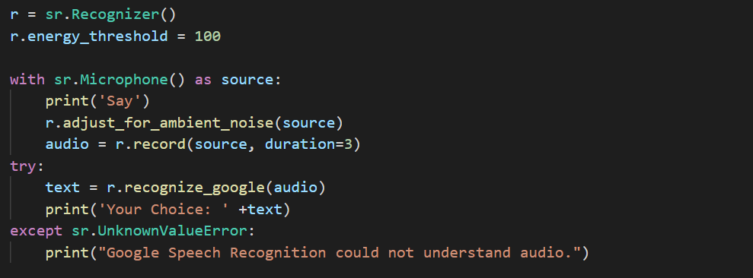

# **TEXT TO SPEECH CONVERTER**

Speech synthesis is the synthetic production of speech. A text – to – speech (TTS) system converts language into speech, alternative systems renders symbolic linguistic representation.

This system also use TTS technology i.e. text-to-speech to speak complex and dynamic information. This converter helps in obtaining output from the system. When any operation occurs in the system the resulting output is in text format but it is useless for visually impaired people. So, the text is then converted to speech and is heard by them. In Voice based email system, when the user gives instructions to read the inbox mails or sent mails then the text-to-speech converter converts the text in mails into the speech and is understood by user.

Linguistic Analysis

1. Phasing
2. Intonation
3. duration

Wave form generation

Utterance composed of words

text

TEXT ANALYSIS

speech

Utterance of composed phonemes

## **GTTS**

This module is Google Text to Speech library python. To install this API in windows platform:

>>shell>pip install gTTS

Example: 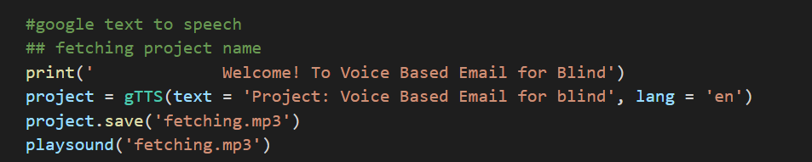

DESIGN

# **SYSTEM DESIGN**

Input Speech using Speech Recognition

Convert Speech to Text using Speech to Text Converter

Choose option and Login

Read a mail

Compose a mail

Tell to Whom You want to send mail

INBOX

Convert text mail to speech

Compose mail as speech to text

MAIL SENT

Output mail as speech using text to speech converter

Logout

This model is divide into 3 phases:

# **PHASE – 1**

The tasks that can be performed using the program developed will be prompted using voice prompt.

User will provide input for the following tasks:

* For reading a mail through G-mail
* For composing a mail through G-mail

The input is expected in form of voice by user which can be converted in form text by Google speech application interface in python.

# **PHASE – 2**

In this phase, user gives the speech input to system which is handled by *speech_recognition* module. It is a python library used for handling the voice requests and converts it into text. Now after receiving the input, the converter saves the response in respective variables used in script.

# **PHASE – 3**

In this phase, our program handles the request of user. Based on the speech input given by user it will launch the modules.

* **Send email through Gmail:** This module will handle request by user to send mail trough gmail account. Once the user is logged in, the message will be send to the desired receiver. *STMP library* is used for this task.
* **Read email through Gmail:** This module will handle the request by user to read mail through gmail account. Once the user is logged in, it starts fetching unread mails for user and will speak it for them with help of *gTTS and playsound library* in python.

SENDING MAIL

Smtplib module was imported using:

Import smtplib

Smtplib contains the class SMTP which is useful to connect with mail servers and can be used to send mails. SMTP is normally used to connect to a mail server and transmit messages.

An SMTP object has a method called sendmail which is usually used to send mails. It has following parameters:

* Sender’s id
* Receiver’s id
* Message to be send which is arranged like RFC822

Also, we require a server as ***smtp.gmail.com***

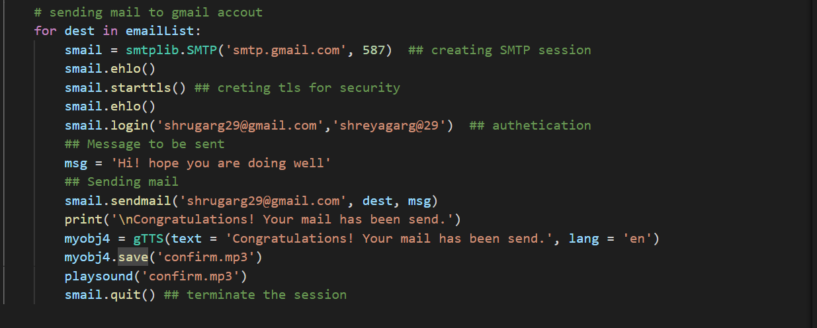

Here, we have sent mail to a number of people at same time by creating list as same message was supposed to be sent. We can also send mails to a particular person by making a dictionary of receiver’s email-id.

READING A MAIL

Here, we’ll import two modules by:

import imaplib

import email

We can automate the process of reading mail from our Gmail account and this can be very useful for people who can’t see so they can use this system to fetch the unread mail from their Gmail account and can listen to it with help of text to speech converter. So to achieve our tasks we just need three functionalities:

* A mail server and username and password
* Login Gmail account
* Servers such as imap.gmail.com and smtp.gmail.com, here we need ***imap.gmail.com***

# **Imaplib – IMAP4 PROTOCOL**

This is the main module which will be used in process of reading mail from gmail account using a python script. Basically, it consists of three classes: IMAP4, IMAP_SSL and IMAP_stream. And IMAP4 is base class. But here we used IMAP_SSL.

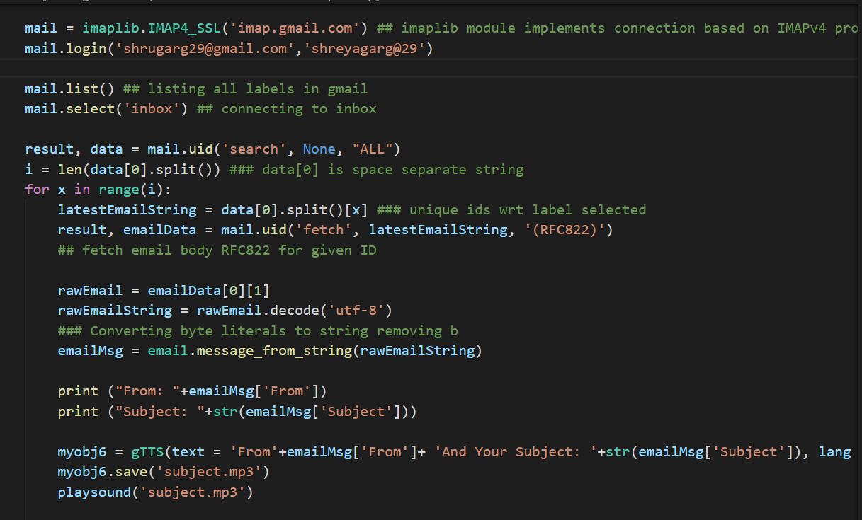

CONCLUSION

The project that we have projected is a system which will help the visually impaired people to access email service efficiently. This system will help in overcoming some drawbacks that were earlier faced by blind people in accessing emails. We have eliminate the use of keyboard shortcuts along with screen readers which will help reducing cognitive load of remembering keyboard shortcuts.

Also, the user might need to feed in information through voice inputs when specified.

This project describes voice mail architecture used by blind to access email and multimedia functions of operating system easily and efficiently on their own. Also, it is helpful for handicapped and illiterate people.

REFERENCES

* <https://www.geeksforgeeks.org/project-idea-voice-based-email-visually-challenged/>
* <https://www.researchgate.net/publication/324526106_A_voice_based_text_mail_system_for_visually_impaired>
* Ummuhanysifa U., Nizar Banu P K, “Voice based Search Engine and Web Pages Reader”. In international journal of advanced researcher in computer and communication engineering (IJARCCE), 2014.